Application Form for Best Teacher Award (North, East, West, South)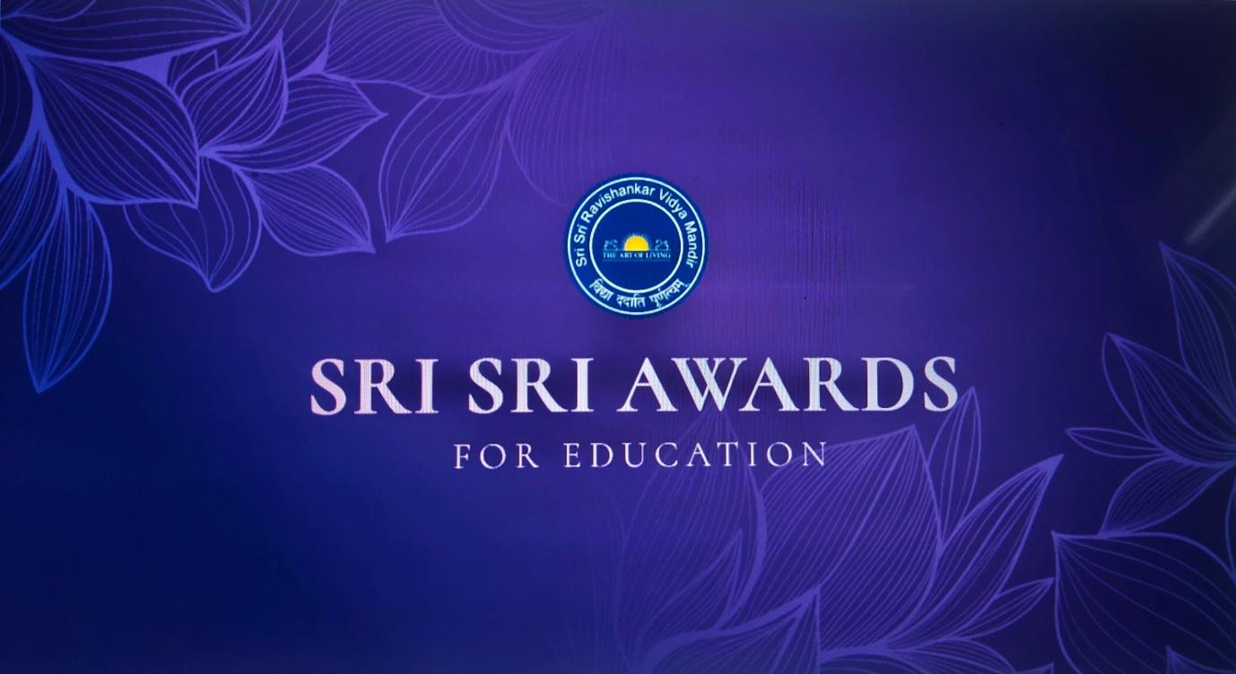

Operating in 156 countries, The Art of Living is a non-profit, educational and humanitarian organization founded in 1981 by the world-renowned humanitarian and spiritual teacher Gurudev Sri Sri Ravi Shankar.
SRI SRI RAVISHANKAR VIDYA MANDIR (SSRVM) TRUST was founded in the year 1999 by Gurudev Sri Sri Ravishankar as the educational wing of the Art of Living, to promote holistic, value-based education bringing together the best of the East and the West. So far, SSRVM Trust has established about 90+ educational institutions ranging from Pre-Primary to P.G. Studies in diverse fields – viz: Management, Computer Study, Ayurveda medicine, including the Sri Sri University in Odisha.
Objectives
To recognize and acknowledge excellence, effort and progress in the field of education across educational
institutions in India;
To empower and promote institutions that focus on holistic development beyond the parameters of academics
and those that deploy the potential of innovative practices and experiments for the improvement of teaching
– learning;
To encourage institutions that involve their parents and other stakeholders in policy making and its education;
To recognize and acknowledge the schools which make their students’ transition smooth from school to career;
To felicitate schools that promote ancient wisdom as well as modern strategies of 21st Century Skills in students;
To recognize and acknowledge schools that promote spirituality, have an environment friendly culture, human
values and peace education;
To honor schools that promote the leadership skills, social and emotional development of students
In an endeavor to promote holistic, value-based education and to encourage schooling institutions across India, SSRVM Trust has instituted the Sri Sri Awards for Education.

Sri Sri Awards for Education

Awards Category: Sri Sri Award for Best Teacher (In the North, West, East and South of India)
Eligibility Criteria to apply for Best Teacher Award
There is no restriction on the size of the school or the age of the school in which the teacher is working. The applicant must have at least 10 years of experience as a teacher. Any person who has authentic knowledge of the teacher’s contribution in the field of education may nominate the teacher for the award by providing the details mentioned in the guidelines. In order to recognize a larger set of teachers, past winners ( Best Teacher of N/E/W/S zones) of this category are not eligible to apply for the second time. However, teachers having received the special mention certificates are eligible to apply for the award.

SL. No. | Particulars | Details
1 | Full Name
2 | Designation
3 | Mobile Number
4 | WhatsApp Number

Academic Background:
Qualifications, list of training received and certifications)
Total years in service (as on 1st July 2023)
Working in this organization since:
List of professional achievement (200 words)
Subjects Taught (Theory/Tutorial/Lab)
Any Volunteering /Sewa Projects you have been part of or done on your own.
Nominated By :
(Nominator could be anyone within or outside the institution)
Name :

Brief profile of Nominator

Please use the below mentioned points as a guideline to explain the reason for nominating the teacher for the award. There is no need to respond to every point below. Please elaborate on points that are relevant to the teacher being nominated. You may include any other parameter you think that deserves mention.

- How does the teacher motivate the students to enhance their level of performance? Explain the approach the teacher has taken to achieve this. Explain instances where the teacher has consistently motivated groups of students (especially those who have underperformed) to improve and sustain their performance.
- What has the teacher done beyond the curriculum to equip the students with the knowledge and skills to reach their fullest potential in order to build good life skills and become a good human being.
- Please quote examples and instances of the teacher exhibiting extraordinary patience and compassion while enhancing the performance of the students.
- How has the teacher updated his or her knowledge and skills over the years to be an effective teacher.
- How has the teacher demonstrated creativity and innovation in her methodology of teaching.
- How has the teacher taken up responsibility in diverse areas in running of the school along with teaching the core subjects.
- How has the teacher contributed to enhance the content of learning material
- How has the teacher contributed to enhance the performance of slow learners.
- What are the various awards won by the teacher within the institution or outside for excelling in the field of education.
- What has been his or her contribution in the education field through presentations in seminars, publishing research papers or conducting workshops for her peers.
- What has been the teacher’s contribution to support and improve the performance of the faculty in the school.

I……………………………………….…. hereby declare that the information furnished above is true, complete and correct to the best of my knowledge and belief. I understand that in the event of my information being found false or incorrect at any stage, the award shall be liable for cancellation / termination without notice or any compensation in lieu thereof.

Date:- Signature of Nominator
Place: -
---------------------------------END OF APPLICATION FORM------------------------------------

